**Assignment 16.5**

**DRIVER:**

Used distributed cache as it is used for keeping in all mapper machines

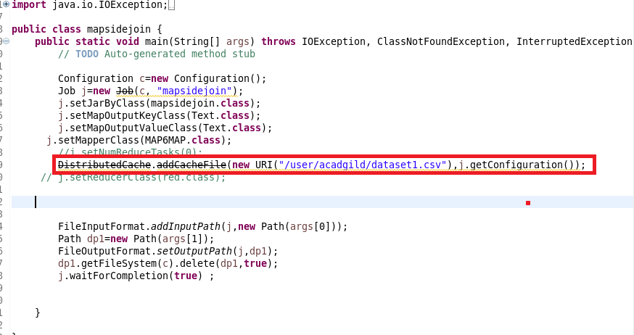

**MAPPER**

**STEP1: OVERRIDING SETUP METHOD**

In mapper we are overriding setup method is used to get the dataset from distributed cache andthen used hashmap and storing the id as key of hashmap and total line as value

**MAPPER METHOD**

In mapper the id is set as key and joining both values separated by comma.

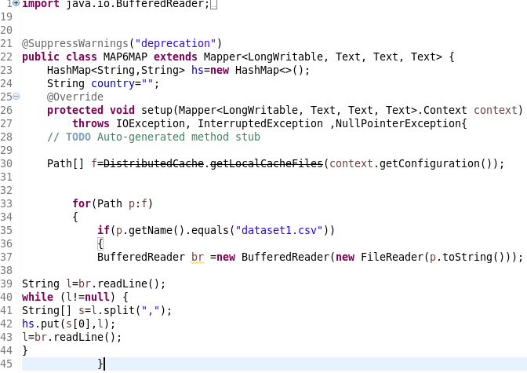

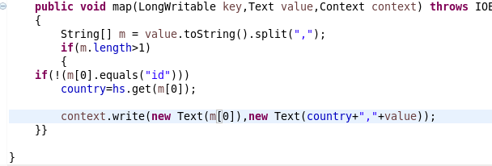

**RUNNING JAR:**

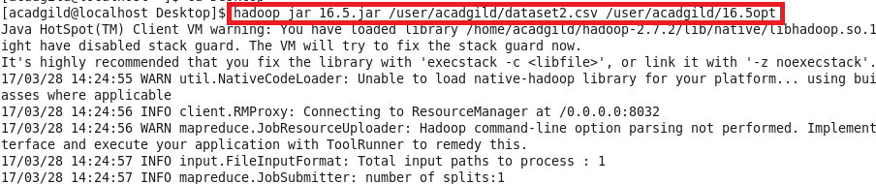

**OUTPUT:**

I have attached the SAMPLE output FILE and we could find both the datasets JOINED AS I could not take the file from VM and file

